**Task 1**

Make a linked list of the numbers taken from the user and Reverse it and also find the

second largest number. (use Javascript)

**Answer** :

let numList = [95, 31, 18, 26, 81, 45];

numList.sort(function(a, b){return a - b});

let secondLargestIndex = numList.length;

console.log("Second Largest Number : ", numList[secondLargestIndex - 2]);

Code Screenshot :

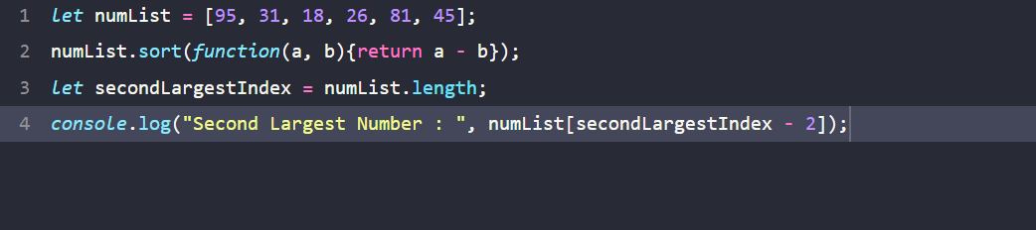

Output :

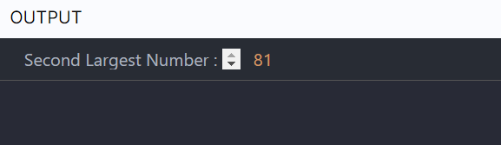

**Task 2 :**

Make a signup, login and logout responsive page.

And implement a user authentication system using different authentication ways.

**App.js :**

import LoginPage from "./component/LoginPage"

import './App.css';

const App = () => (

<LoginPage />

)

export default App;

**component/LoginPage/index.js :**

import {useState} from "react"

import "./index.css"

const LoginPage = () => {

const [title, setTitle] = useState("Login")

return(

<div className="main-container">

<div className="card-container">

<h1 className="main-heading">{title}</h1>

{title === "Login" ? <div></div> : <div>

<input type="text" placeholder="Name" className="input-container" />

</div>}

<div>

<input type="email" placeholder="Email" className="input-container" />

</div>

<div>

<input type="password" placeholder="Password" className="input-container" />

</div>

<div className="button-container">

<button type="button" className={title === "Sign Up" ? "button btn-selected" : "button"} onClick={() => setTitle("Sign Up")}>Sign Up</button>

<button type="button" className={title === "Login" ? "button btn-selected" : "button"} onClick={() => setTitle("Login")}>Login</button>

</div>

</div>

</div>

)

}

export default LoginPage

**component/LoginPage/index.css:**

.main-container{

    background-color: #186cf2;

    height: 100vh;

    display: flex;

    flex-direction: column;

    align-items: center;

    justify-content: center;

}

.card-container{

    background-color: #f7f9fc;

    width: 300px;

    height: 350px;

    border-radius: 8px;

    padding: 20px;

}

.main-heading{

    color: black;

    font-size: 30px;

    font-family: "Roboto";

    font-weight: 900;

    text-align: center;

}

@media screen and (min-width: 768px){

    .card-container{

        width: 400px;

        height: 450px;

    }

    .main-heading{

        font-size: 40px;

    }

}

.input-container{

    background-color: #e3eeff;

    border: 1px solid #04142e;

    border-radius: 4px;

    padding-left: 8px;

    width: 100%;

    margin-bottom: 15px;

    height: 45px;

}

.button-container{

    display: flex;

    align-items: center;

    justify-content: center;

    margin-top: 20px;

}

.button{

    width: 120px;

    height: 45px;

    font-family: "Roboto";

    font-weight: 700;

    color: black;

    border-radius: 50px;

    cursor: pointer;

    border: 0px;

    font-size: 18px;

    margin-right: 15px;

    background-color: #d7d9db;

}

.btn-selected{

    color: #ffffff;

    background-color: #3a36f7;

}